Functional Specification Document
  - OMEGA – Open Market Execution Gateway
  - Syndication
  - v0.01

Document Control
Revision History
Revision # | Release Date | Summary of Changes | Author
0.01 | 15 Jan 2026 | Initial draft. | Christian Quah

Reviewer Name (Designation) | Reviewed Version # | Date

Approver Name (Designation) | Approved Version # | Date

Table of Contents
1 Introduction 7
1.1 Purpose of Document 7
1.2 Scope 7
1.3 Definitions, Acronyms and Abbreviations 7
1.4 Reference 8
2 Functional Requirements 8
2.1 Purpose of Module 8
2.2 Actors 8
2.3 Process Diagrams 9
2.3.1 Syndication Details 9
2.3.2 Syndication Allotment 10
2.4 BPMN Workflow 11
2.5 State Transition Diagram 11
2.6 Use Cases 13
2.7 View Syndication Details 15
2.7.1 Description 15
2.7.2 Preconditions 15
2.7.3 Business Requirements 15
2.7.4 Post Conditions 15
2.7.5 Syndication Details Listing Page 16
2.7.6 Syndication Details Page 17
2.8 Update Syndication Details 26
2.8.1 Description 26
2.8.2 Preconditions 26
2.8.3 Business Requirements 27
2.8.4 Post Conditions 27
2.8.5 Syndication Details Page 27
2.8.6 Confirmation Prompt 27
2.9 Approve/Reject Syndication Details Approval Request 28
2.9.1 Description 28
2.9.2 Preconditions 28
2.9.3 Business Requirements 29
2.9.4 Post Conditions 29
2.9.5 Syndication Details Page 29
2.9.6 Confirmation Prompt 30
2.9.7 Cancellation Banner 31
2.10 Withdraw Syndication Details Approval Request 31
2.10.1 Description 31
2.10.2 Preconditions 32
2.10.3 Business Requirements 32
2.10.4 Post Conditions 32
2.10.5 Syndication Details Page 32
2.10.6 Confirmation Prompt 32
2.11 Cancel Syndication 33
2.11.1 Description 33
2.11.2 Preconditions 33
2.11.3 Business Requirements 33
2.11.4 Post Conditions 33
2.11.5 Confirmation Prompt 33
2.12 Override MEPS+ Validation Error 34
2.12.1 Description 34
2.12.2 Preconditions 34
2.12.3 Business Requirements 34
2.12.4 Post Conditions 35
2.12.5 Syndication Details Page 35
2.12.6 Confirmation Prompt 35
2.13 View Syndication Allotments 36
2.13.1 Description 36
2.13.2 Preconditions 36
2.13.3 Business Requirements 36
2.13.4 Post Conditions 36
2.13.5 Syndication Allotment Listing Page 36
2.13.6 Syndication Allotment Page 38
2.14 Conduct Retail Allotment in OMEGA 43
2.14.1 Description 43
2.14.2 Preconditions 44
2.14.3 Business Requirements 44
2.14.4 Post Conditions 44
2.15 Upload Allotment File 44
2.15.1 Description 45
2.15.2 Preconditions 45
2.15.3 Business Requirements 45
2.15.4 Post Conditions 45
2.15.5 Upload File Modal 45
2.15.6 File Format and Validations 46
2.15.7 Data Table 47
2.16 Approve/Reject File Upload Approval Request 48
2.16.1 Description 48
2.16.2 Preconditions 48
2.16.3 Business Requirements 48
2.16.4 Post Conditions 48
2.16.5 Syndication Allotment Page 48
2.16.6 Confirmation Prompt 49
2.17 Withdraw Allotment File Upload Approval Request 50
2.17.1 Description 50
2.17.2 Preconditions 50
2.17.3 Business Requirements 50
2.17.4 Post Conditions 50
2.17.5 Syndication Allotment Page 51
2.17.6 Confirmation Prompt 51
2.18 Conduct Retail Allotment Outside of OMEGA 52
2.18.1 Description 52
2.18.2 Preconditions 52
2.18.3 Business Requirements 52
2.18.4 Post Conditions 52
2.18.5 Syndication Allotment Page 52
2.19 Upload Placement Tranche 52
2.19.1 Description 53
2.19.2 Preconditions 53
2.19.3 Business Requirements 53
2.19.4 Post Conditions 53
2.19.5 Syndication Allotment Page 53
2.20 Verify Overall Allotment 53
2.20.1 Description 54
2.20.2 Preconditions 54
2.20.3 Business Requirements 54
2.20.4 Post Conditions 54
2.20.5 Syndication Allotment Listing Page 54
2.21 Download Allotment Result Report 54
2.21.1 Description 54
2.21.2 Preconditions 54
2.21.3 Business Requirements 54
2.21.4 Post Conditions 55
2.21.5 Syndication Allotment Page 55
3 Validations Against MEPS+ 55

Introduction

Purpose of Document
This Functional Specification Document is used to clearly define the intended functionality of OMEGA.
OMEGA is a platform that supports MAS’ central banking functions related to market operations and benchmark administration. OMEGA aims to improve business efficiency by leveraging on technology and design thinking, minimising manual intervention, re-engineering business processes and improving system resiliency.
OMEGA consists of several modules. This document outlines the functionality of the Bonds and Bills module, focusing on features, functions, and behaviour specifically for syndications, without detailing how these functionalities will be technically implemented. It aims to:
- Establish a shared understanding of the system's functional scope;
- Provide a clear and unambiguous description of each functional requirement;
- Ensure that the developed system meets the identified business needs and user expectations;
- Facilitate effective communication and collaboration among all project stakeholders;
- Serve as a baseline for system development, testing, and implementation; and
- Manage and control changes to the system's functionality through a defined change management process.

Scope
The Bonds and Bills module allows MAS internal users to perform the following functionalities:
- Update syndication details;
- Submit syndication details for approval or withdraw submissions;
- Approve / reject syndication details approval requests as part of the maker-checker process;
- Cancelling a syndication;
- Override the syndication details with the data from MEPS+;
- Upload public offer results from ESA;
- Upload placement tranche on behalf of the B&D Bank;
- Verify syndication allotment.

Definitions, Acronyms and Abbreviations
Acronym | Description
AGD | xxx
B&D | Billing and Delivery
BPMN | Business Process Model and Notation
CDP | Central Depository Pte Limited
ESA | Electronic Securities Application
FI | Financial Institution
FMBS | xxx
ISIN | International Securities Identification Number
MAS | Monetary Authority of Singapore
MEPS+ | MAS Electronic Payment System+
OMEGA | Open Market Execution Gateway
PD | Primary Dealer
PDF | Portable Document Format
Retail PDs | DBS, OCBC, UOB
SFTP | Secure File Transfer Protocol
SGS | Singapore Government Securities
SSB | Singapore Savings Bonds
Table 1: Acronyms used in document

Reference
The following documents are referenced throughout this functional specification and should be consulted for additional context, detailed requirements, and technical information that supports the functional requirements described in this document.
- Logic for Issue Code.pdf
- MAS_OMEGA – Interface Specifications Document (MAS Website).docx
- MAS_OMEGA - Interface Specifications Document (FIs and CDP).docx
- MAS_OMEGA – Functional Specifications Document (Bid Collation).docx
- MAS_OMEGA – Functional Specifications Document (Allotment).docx
- MAS_OMEGA – Functional Specifications Document (SSBs).docx
- MAS_OMEGA – Functional Specifications Document (Common Functions).docx
- MAS_OMEGA – Functional Specifications Document (Administration).docx
- MAS_OMEGA – Functional Specifications Document (Reports).docx
- MAS_OMEGA – Additional Information (Error Messages).xlsx – This file contains a list of validations in each module and their corresponding error messages.
- MAS_OMEGA – Additional Information (System Notifications and Emails).xlsx – This file contains a list of system notifications and emails in each module and their corresponding content.

Functional Requirements

Purpose of Module
MAS internal users can manage syndication details and their publication to the MAS website and Retail PDs.
OMEGA contains outbound interfaces to the MAS website, Retail PDs, MEPS+, FMBS and AGD to send over the necessary information for the publication of syndication details and results. OMEGA also contains inbound interfaces from MEPS+ to receive the security information upon its creation. In addition, notifications in the form of emails and/or system notifications are available.

Actors
The actors identified for this module are as follows:
Actors | Description
Syndication Details Maker | The entity responsible for updating or unpublishing syndication details and cancelling syndications.
Syndication Details Checker | The entity responsible for approving the update or unpublishing of syndication details and cancelling syndications.
Syndication Details Viewer | The entity who is only allowed to view syndication detail but not allowed to manage them nor approve them for publication to the MAS website and Retail PDs.
Syndication Allotment Maker | The entity responsible for uploading public offer allotment and placement tranche.
Syndication Allotment Checker | The entity responsible for approving public offer allotment and verifying the syndication allotment.
Syndication Allotment Viewer | The entity who is only allowed to view syndication allotment but not allowed to manage them nor approve them.
Table 2: Actors of module

Process Diagrams

Syndication Details
The figure below shows the high-level activities when updating syndication details: 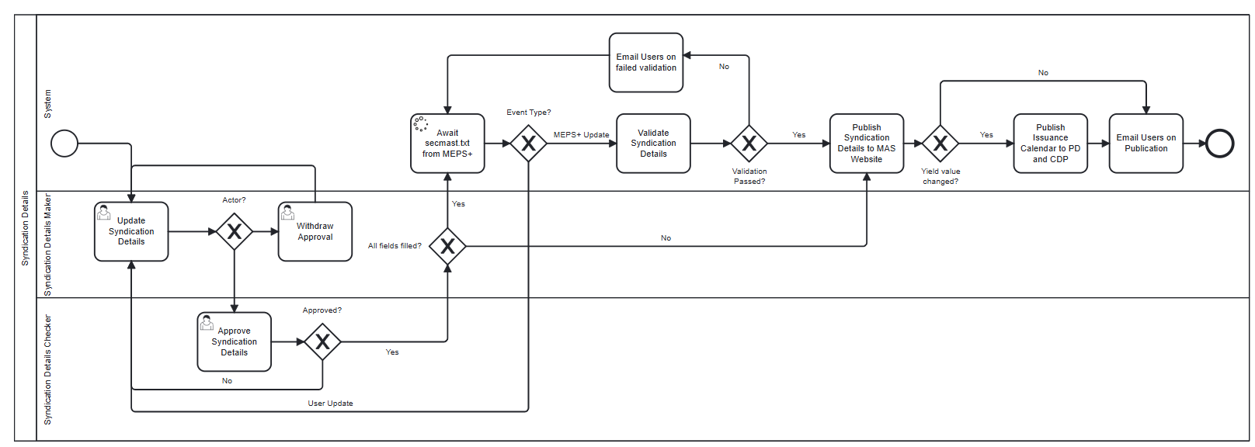
Figure 1: Activities when updating syndication details
OMEGA creates the syndication details record with status of “New” when the syndication record is approved in the issuance calendar. This system-initiated record is linked to the issuance calendar and will be removed if the syndication record is approved to be removed from the issuance calendar. When updating the syndication details, some of the fields are referenced from data from the issuance calendar (until OMEGA receives the secmast.txt file from MEPS+) and the parameter settings.
Upon submission, the checkers can view the syndication details and determine whether to approve or reject it. If the syndication details are rejected, the syndication details are sent back to the maker for edits.
If there are input fields for the syndication details that do not have a value, upon approval, the syndication details will be published to the MAS website as “TBA” for the fields that do not have a value. If there is a value for Yield and Price in the syndication details, there will be a publication of the issuance calendar including the syndication record to the Retail PDs and CDP as well.
If all the input fields have a value, and the syndication details are approved, OMEGA sends an email to notify users in a distribution list to create the security in MEPS+ and waits to receive the secmast.txt file from MEPS+. Upon receiving the file, OMEGA processes the file and validates any syndication details with status as pending the security to be created from MEPS+, against the data in secmast.txt. If the validations fail, an email is sent to notify users of the failed validations, so that users can address the reason(s) for failed validation accordingly. There will be 3 possible courses of action:
- Overwrite the data in OMEGA with data from MEPS+; or
- Amend the security details in MEPS+ and re-send the secmast.txt file into OMEGA; or
- Update the syndication details in OMEGA.
For options 2 and 3, OMEGA will do another round of processing and validation of the secmast.txt file. Refer to MAS OMEGA – Interface Functional Specifications Document (MEPS+, FMBS and AGD).docx for the validations made within the secmast.txt.
If the validations pass, the syndication details are published to the MAS Website. If there are changes to the value of Yield and Price in the syndication details, the issuance calendar including the syndication record is sent to the FIs and CDP as well.

Syndication Allotment
The figure below shows the high-level activities for syndication allotment:
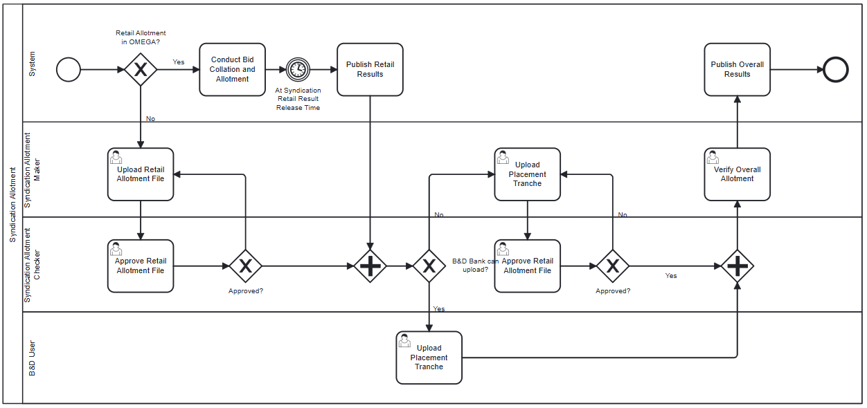
Figure 2: Activities for syndication allotment
Once the syndication details have been validated against MEPS+ and are published, the syndication allotment process begins.
Should the retail allotment for syndication be conducted in OMEGA, it will follow the retail Bid Collation process as defined in MAS_OMEGA – Functional Specifications Document (Bid Collation).docx. The allotment will be conducted using a derivative of the Quantity Ceiling Format as described in MAS_OMEGA – Functional Specifications Document (SSBs).docx. Once the retail allotment has been completed and verified, the retails results will be published to the PDs. Downstream interface files to AGD, MEPS+ and FMBS will not be generated and sent, the overall allotment has to be verified before this can occur.
If the retail allotment is conducted outside of OMEGA, it will be done in ESA and the results of the allotment will be uploaded into OMEGA (subject to maker-checker process).
Once the retail allotment is completed, the B&D Bank will upload the placement tranche. Should the B&D bank be unable to proceed with the upload, Syndication Allotment Makers can upload the file on behalf of the B&D Bank (subject to maker-checker process).
Once the placement tranche has been uploaded and approved (where applicable), the Syndication Allotment can be verified. After verification, the interface files to AGD, MEPS+ and FMBS will be generated and sent.

BPMN Workflow
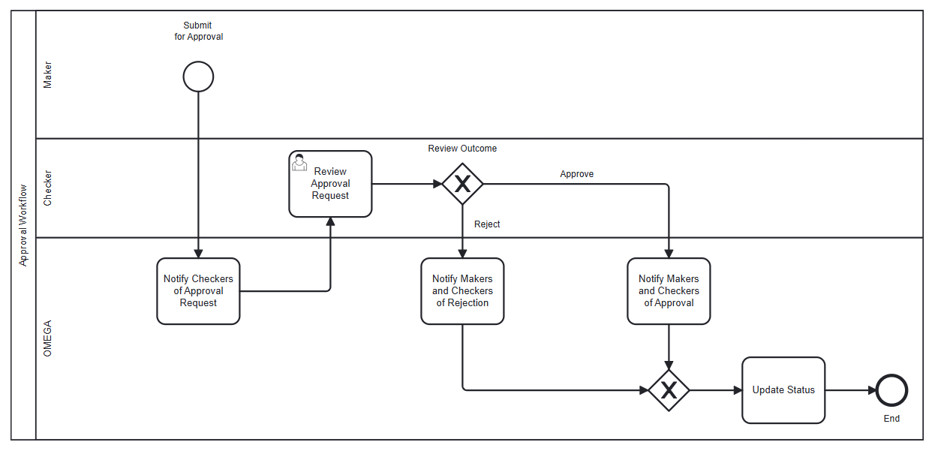
Figure 3: BPMN approval workflow for syndication details/allotment
In this module,
- An instance of the BPMN workflow above is created when a maker submits a request for approval.
- OMEGA notifies the checkers of the approval request that is pending their review.
- The checker reviews the approval request with the option to approve or reject the request.
- When approved, the makers and the checkers are notified of the approval, OMEGA updates the status of the syndication details / allotment.
- When the request is rejected, the makers and the checkers are notified of the rejected request, and OMEGA reverts the status of the syndication details/allotment to its previous status; unless at “Pending Publication”, the status is shown as “Rejected”. For this issue code and issue date, no changes to the syndication details are published on the MAS Website until the syndication details are updated and approved.

State Transition Diagram
The figures below show the possible status transitions that syndication details and syndication allotment may undergo, and the conditions required to trigger these transitions.
The diagram below represents the transitions when not all information of the syndication details have been input. There will not be verification with MEPS+.
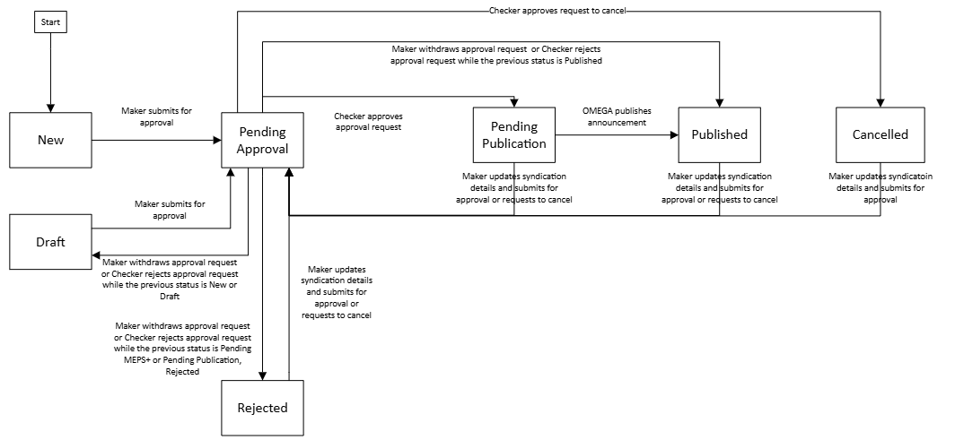
The diagram below represents the transitions when all information of the syndication details have been input. There will be verification with MEPS+.

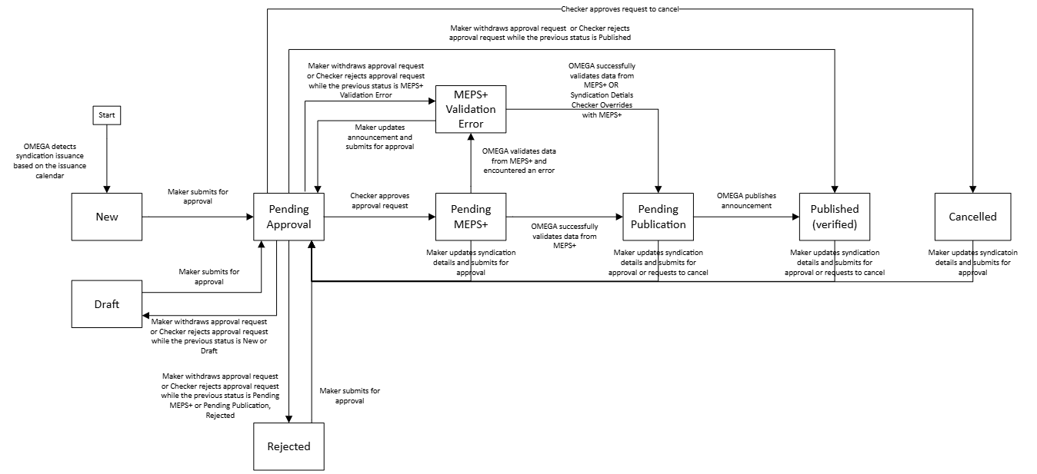

The diagram below represents the state transitions for the Syndication Allotment.
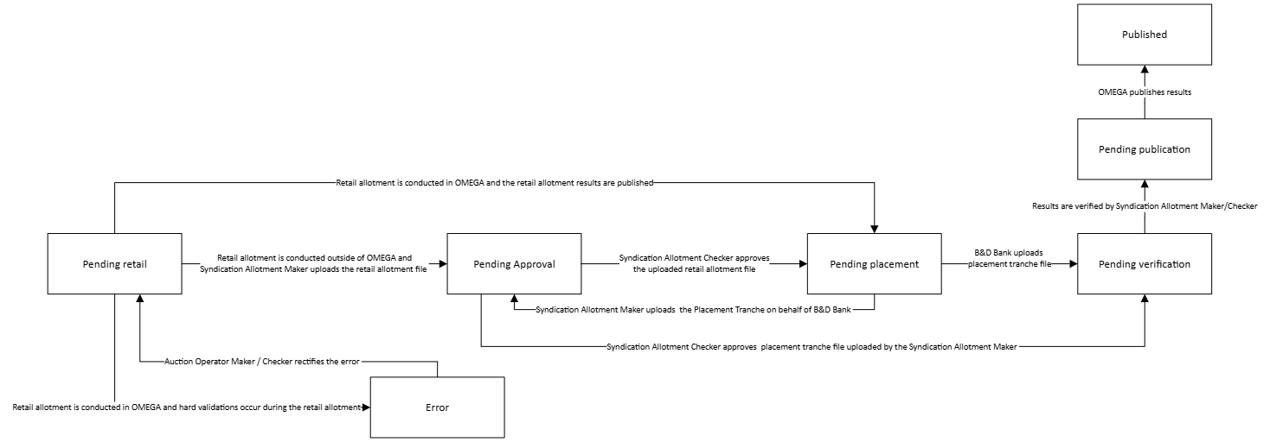

Figure 4: State transition diagrams

Use Cases
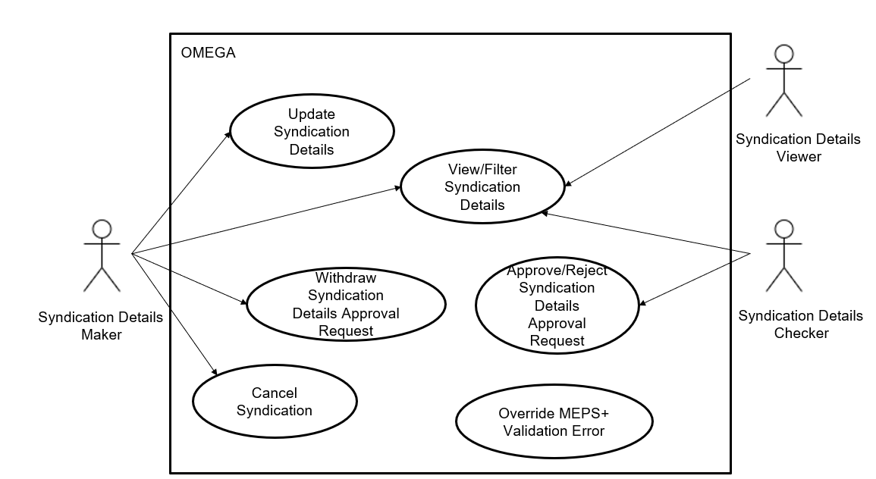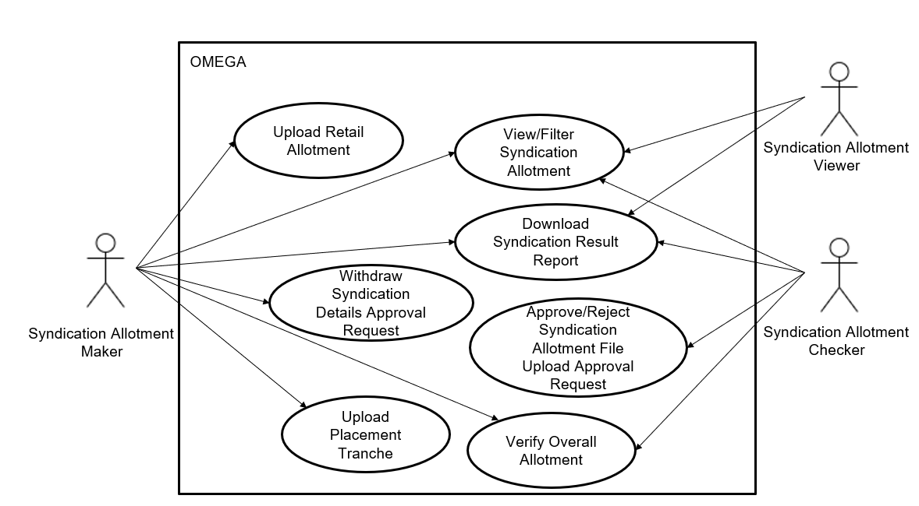
Figure 5: Use case diagrams
The use cases covered within this module are:
- 2.7 View Syndication Details
- 2.8 Update Syndication Details
- 2.10 Withdraw Syndication Details Approval Request
- 2.9 Approve/Reject Syndication Details Approval Request
- 2.11 Cancel Syndication
- 2.12 Override MEPS+ Validation Error
- 2.13 View Syndication Allotments
- 2.14 Conduct Retail Allotment in OMEGA
- 2.15 Upload Allotment File
- 2.16 Approve/Reject Allotment File Upload Request
- 2.17 Withdraw Allotment File Upload Request
- 2.18 Conduct Retail Allotment Outside of OMEGA
- 2.19 Upload Placement Tranche
- 2.20 Verify Overall Allotment
- 2.21 Download Syndication Results Report

View Syndication Details

Description
This use case enables users to view and filter syndication details.

Preconditions
- User logs in to the Intranet Portal.
- User accesses the Syndication tab in Announcement Listing Page.

Business Requirements
- Role-based Access Control:
  - Syndication Details Maker
  - Syndication Details Checker
  - Syndication Details Viewer
- Pre-population of Data from Issuance Calendar: The rows in the syndication details data table will be available based on the existence of a row in the Syndication tab of the SGS Bonds issuance calendar, regardless of the existence of data in that row. Should the values in the issuance calendar be blank, the listing page will show the respective value for that column as “-“. The details of the record in the Syndication Details Listing Page will be pre-populated from the latest approved issuance calendar, except for the Last modified by and Last modified date/time columns, which will display “-“. The Security information in the sub-header of the Syndication Details Page will also be pre-populated from the latest approved issuance calendar.

Post Conditions
- User views the syndication details for a particular syndication issuance.

Syndication Details Listing Page
The Syndication Details Listing Page contains the following screen elements:
- Page Header
- Data Table Action Bar
- Data Table
Default Sorting: (1) ascending order of Year / serial
Default Filter: Only show syndication records from the SGS Bonds Issuance Calendar of the current year.
Custom Filter Tag Behaviour: When the default filter is used, the Year field in the Data Table Action Bar displays the current year as well as a tag . This tag is not closable by users. If any other years are selected, the tag is replaced with another tag 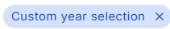 . This tag is closable by users. If closed, the year filter is reset to show the default filter.

Wireframe
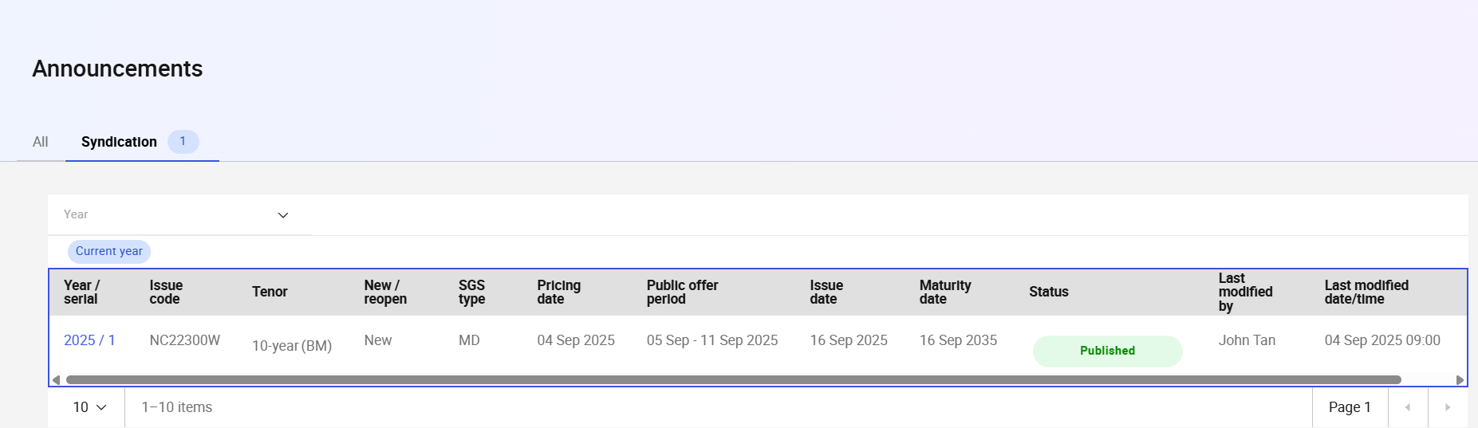
Figure 6: Announcement Listing Page (Syndication Tab)

Page Header
S/N | Name | Type  (Max Length) | Validation Rules | Remarks
1 | Announcement | Page title
2 | Tabs  - Auction  - Syndication | Tab |  | The Syndication tab will contain a tag with a numerical value relating to the number of syndications in the current year.
Table 3: Page Header Screen Elements

Data Table Action Bar
S/N | Name | Type  (Max Length) | Validation Rules | Remarks
1 | Year | Multiselect Dropdown |  | To filter for Issuance Calendar years.  Options available are the 4-digit value of the years of the existing Issuance Calendars in OMEGA.
Table 4: Data Table Action Bar Screen Elements

Data Table
S/N | Name | Type  (Max Length) | Validation Rules | Remarks
1 | Year / serial | Label (with hyperlink) |  | Clicking on the hyperlink navigates the user to the Syndication Details Page based on the year and serial no.
2 | Issue code | Label |  | Will be “-“ if there is no value for issue code.
3 | Tenor | Label |  | For SGS bonds, add “(BM)” or “(Non-BM)” depending on whether the Benchmark field value is “Yes” or “No”.  Will be “-“ if there is no value for Tenor.
4 | New / reopen | Label |  | Will be “-“ if there is no value for New / reopen.
5 | SGS type | Label |  | Will be “-“ if there is no value for SGS type.
6 | Pricing date | Label |  | Will be “-“ if there is no value for Pricing date.
7 | Public offer period | Label |  | Will be “-“ if there is no value for Public offer period.
8 | Issue date | Label |  | Will be “-“ if there is no value for Issue date.
9 | Maturity date | Label |  | Will be “-“ if there is no value for Maturity date.
10 | Status |  |  | Refer to 2.5 State Transition Diagram for possible values.
11 | Last action by | Label |  | Display the name of the user who made the last action that resulted in a change of status.  If it was an update by the system, “OMEGA” would be reflected.
12 | Last action on | Label |  | Display the date and time of the last action that resulted in a change of status.
Table 5: Data Table Screen Elements

Syndication Details Page
The Syndication Details Page contains the following screen elements:
- Page Header
- Sub-Header
- Submission History
- Placement Details
- Coupon & Interest
- Coupon Payment Dates
- Offering Details
- Internal Remarks
- Action Button Row
For Viewers and Checkers, the input fields are displayed as read-only fields.

Wireframe
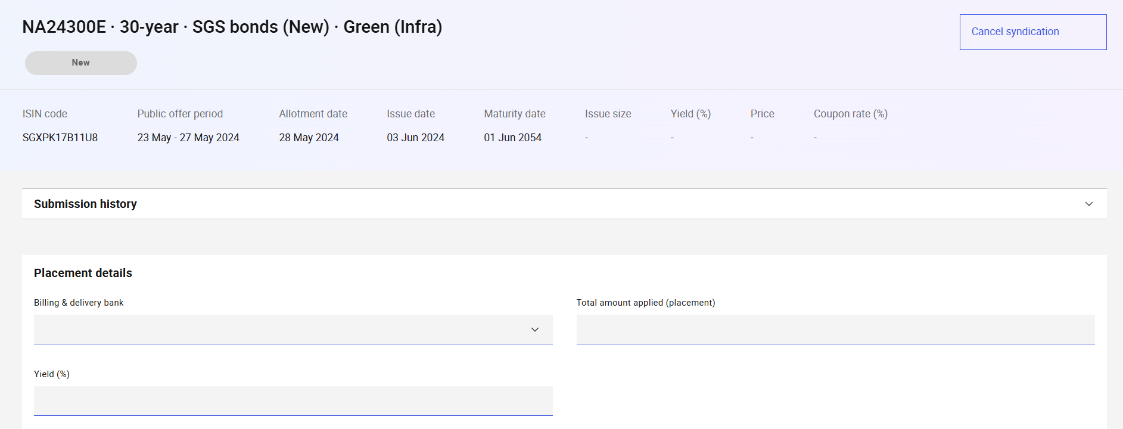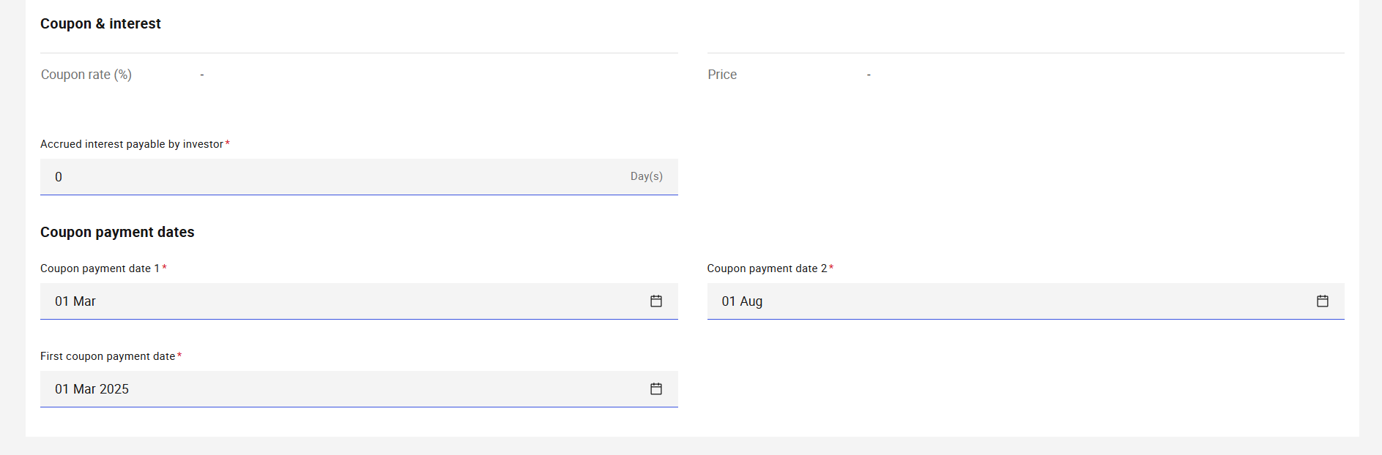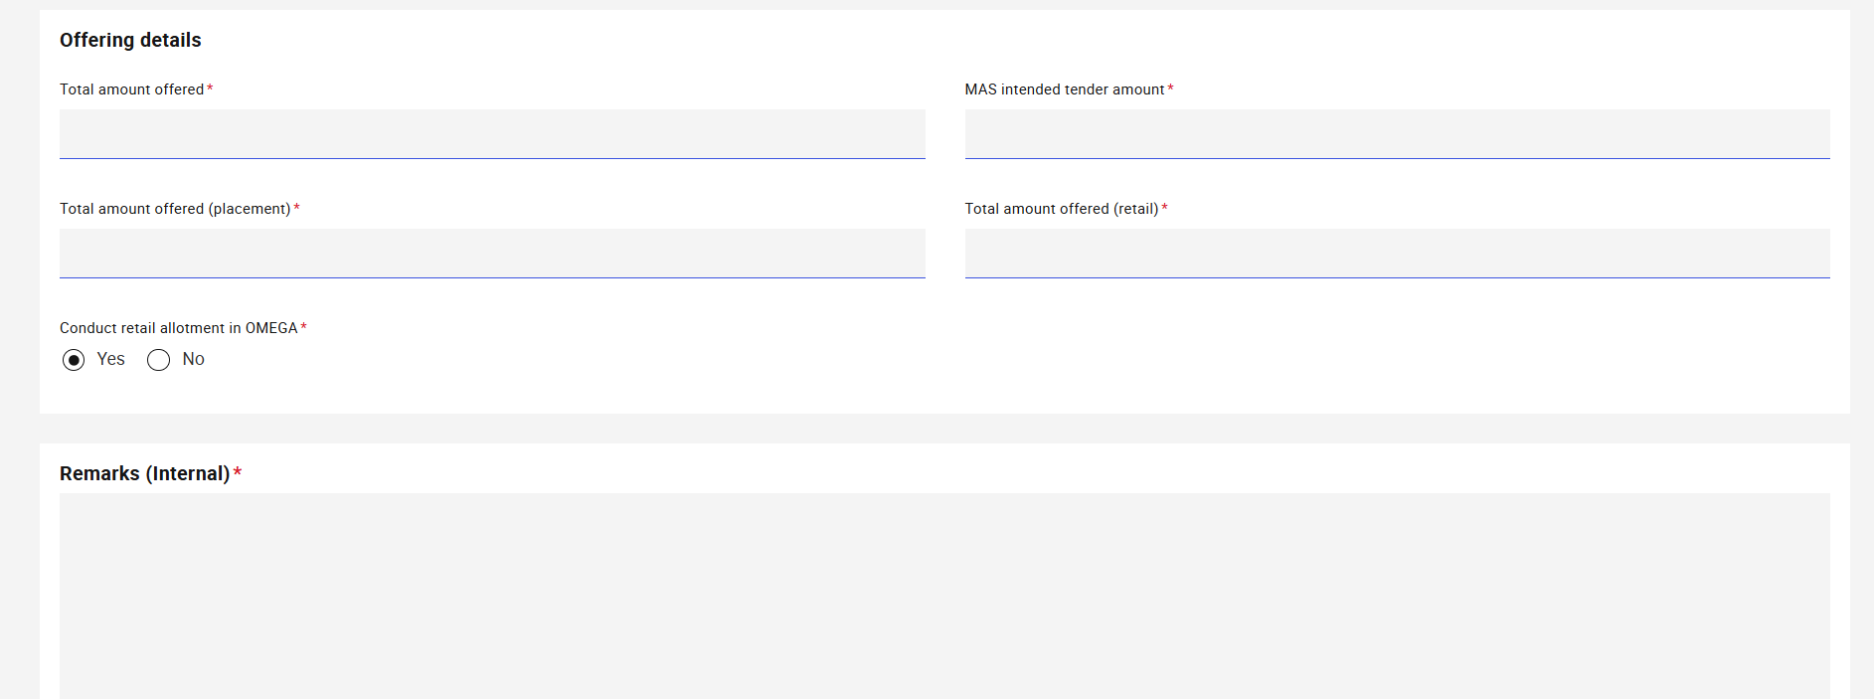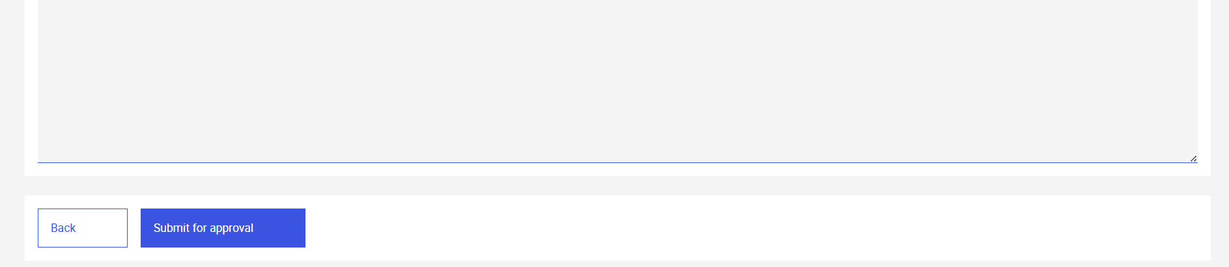
Figure 7: Syndication Details Page (SGS Bond – New)
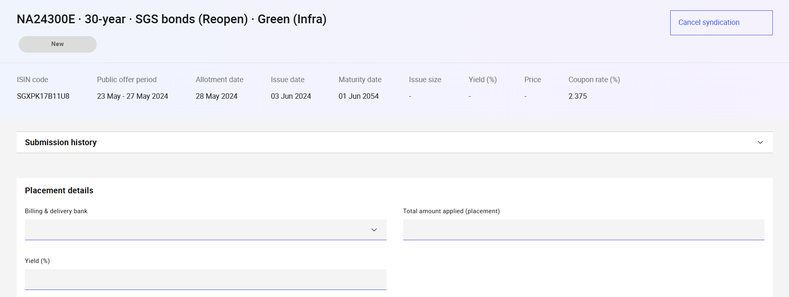
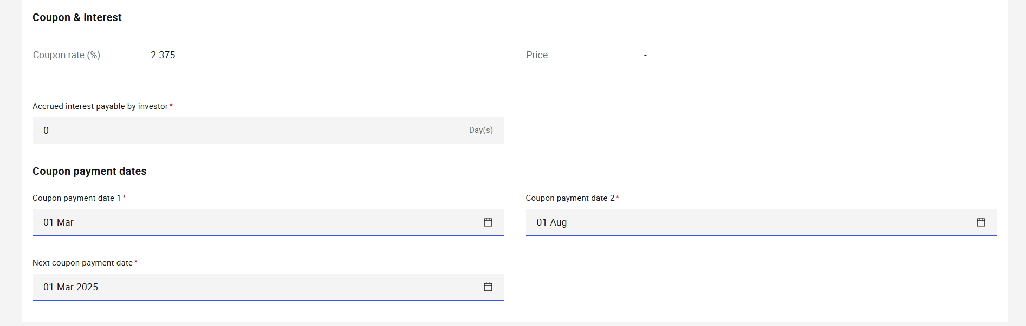 Figure 8: Syndication Details Page (SGS Bonds – Reopened)

Page Header
S/N | Name | Type  (Max Length) | Validation Rules | Remarks
1 | Page Title | Page Title |  | To display Year/serial if issue code is not available.  Displays the Security type and Issue code of the syndication as “{issueCode} ·  {tenor} · {securityType} ({newReopen})· · {sgsType}”  e.g. "N525100T·  5-year · SGS Bonds (Re-open) · SGS (MD)"
2 | Status | Status Pill Indicator |  | Displays the status of the announcement. For example, .
3 | Header Action Buttons | Button Group |  | Displays the following buttons:  - Cancel syndication  The buttons are only available to Syndication Details Makers
Table 6: Page Header Screen Elements

Sub-Header
S/N | Name | Type  (Max Length) | Validation Rules | Remarks
1 | ISIN code | Label |  | Will be “-“ if there is no value from the issuance calendar.
2 | Public offer period | Label |  | Will be “-“ if there is no value from the issuance calendar.
3 | Allotment date | Label |  | Will be “-“ if there is no value from the issuance calendar.
4 | Issue date | Label |  | Will be “-“ if there is no value from the issuance calendar.
5 | Maturity date | Label |  | Will be “-“ if there is no value from the issuance calendar.
6 | Issue size | Label |  | Will be “-“ if there is no approved value for Total amount offered from the Offering details section of this page.
7 | Yield (%) | Label |  | Will be “-“ if there is no approved value for Yield (%) in the Placement details section of this page.
8 | Price | Label |  | Will be “-“ if there is no value approved value for Yield (%) in the Placement details section of this page.
9 | Coupon rate (%) | Label |  | For Reopened SGS Bonds:  If there is no value for issue code from the issuance calendar - coupon rate will be “-“  If the issue code is available in the issuance calendar – coupon rate value is fetched from the original issue.  For New SGS Bonds will be “-“ if there is no approved value for Yield (%) in the Placement details section of this page.
Table 7: Security Information Screen Elements

Submission History
Refer to MAS_OMEGA – Functional Specifications Document (Common Functions).docx for the screen elements used and its functionalities.

Placement Details
S/N | Name | Type  (Max Length) | Validation Rules | Remarks
1 | Billing & delivery bank | Dropdown |  | List to be sourced based on the Counterparties with Role of “B&D Bank”. Refer to MAS_OMEGA – Functional Specifications Document (Administration).docx for more information on Counterparties.  Once a bank is chosen and approved, this field will no longer be editable.
2 | Total amount applied (placement) | Text  Max length: 13 | Hard validations:  - Divisible by minimum denomination of the security type with no remainder. | Large denomination shortcut applies for this field. Refer to MAS_OMEGA – Functional Specifications Document (Common Functions).docx for more details.
3 | Yield | Numeric  Max length: 6 | Hard validations:  - Maximum 2 decimal places. | Changes to this field will require another verification against MEPS+, if already verified.
Table 8: Placement Details Screen Elements

Coupon & Interest
S/N | Name | Type  (Max Length) | Validation Rules | Remarks
1 | Coupon rate (%) | Label |  | For New SGS Bonds, this will be a system-generated field by rounding down the value of Yield (%) in the Placement Details section to the nearest 0.125%. The coupon rate calculation will be triggered on change of the Yield (%) value.  For Reopened SGS Bonds, obtain the coupon rate of the original issue from the security table.
2 | Price | Label |  | Price is a system-generated field calculated based on the Yield (%) from the Placement Details section, Coupon rate (%) in this section and accrued interest days. The calculation of this field will be triggered on change of the value of Yield (%) in the Placement Details section.  For the specific calculation formula used, refer to the MAS_OMEGA – Functional Specifications Document (Allotment).docx.
3 | Accrued interest payable by investor | Numeric  Minimum value: 0  Maximum value: 365 |  | For Reopened SGS Bonds, the value is computed based on the number of days between the previous coupon payment date (which is obtained from the original issue from security table) and the issue date of Reopened SGS Bonds. The value is 0 for New SGS Bonds.
Table 9: Coupon & Interest Screen Elements

Coupon Payment Dates
S/N | Name | Type  (Max Length) | Validation Rules | Remarks
1 | First coupon payment date | Date Picker | Hard validations:  - Must be after issue date | Visible only for New SGS Bonds.  Changes to this field will require another verification against MEPS+, if already verified.  The field auto-populates for Syndication Details makers when the field is blank and both issue date and maturity date are available in the latest approved issuance calendar. The value is calculated by first deriving the year-agnostic coupon payment dates from the approved maturity date and the security type's coupon payment frequency, then applying them to the approved issue date to find the first coupon payment date after the issue date.  For example, if the maturity date is in Jun 2067 and the coupon payment frequency is half-yearly, then the coupon payment dates would be on the 1st calendar day of the month of the maturity day and 6 months before (i.e. 01 Jun and 01 Dec of every year). If the current issue date is before 01 Jun 2025, the next coupon payment date would be 01 Jun 2025. If the current issue date is after 01 June 2025, then the next coupon payment date would be 01 Dec 2025.
2 | Next coupon payment date | Date Picker | Hard validations:  - Must be after issue date. | Visible only for Reopened SGS Bonds.  Changes to this field will require another verification against MEPS+, if already verified.  The field auto-populates for Syndication Details makers when the field is blank and both issue date and maturity date are available in the latest approved issuance calendar. The value is calculated by first deriving the year-agnostic coupon payment dates from the approved maturity date and the security type's coupon payment frequency, then applying them to the approved issue date to find the first coupon payment date after the issue date.  For example, if the maturity date is in Jun 2067 and the coupon payment frequency is half-yearly, then the coupon payment dates would be on the 1st calendar day of the month of the maturity day and 6 months before (i.e. 01 Jun and 01 Dec of every year). If the current issue date is before 01 Jun 2025, the next coupon payment date would be 01 Jun 2025. If the current issue date is after 01 June 2025, then the next coupon payment date would be 01 Dec 2025.
3 | Coupon payment dates | Date Picker | Hard validations:  - The second value should be later than the first value. | This field is in DD MMM (e.g. 01 Jan). While the date picker component includes the year, the value of the year is discarded when selecting dates in this field. For example, even though the user selects the date “26 Dec 2025”, the field should display “26 Dec” and the database should also store the corresponding value without the year.  Changes to this field will require another verification against MEPS+, if already verified.  The field auto-populates for Syndication Details makers when the field is blank and approved maturity date is available in the issuance calendar. The value is calculated by from the approved maturity date and the security type's coupon payment frequency.  For example, if the maturity date is in Jun 2067 and the coupon payment frequency is half-yearly, then the coupon payment dates would be on the 1st calendar day of the month of the maturity day and 6 months before (i.e. 01 Jun and 01 Dec).
Table 10: Coupon Payment Dates Screen Elements

Offering Details
S/N | Name | Type  (Max Length) | Validation Rules | Remarks
1 | Total amount offered | Text  Max length: 13 | Hard validations:  - Divisible by minimum denomination of the security type with no remainder. | Large denomination shortcut applies for this field. Refer to MAS_OMEGA – Functional Specifications Document (Common Functions).docx for more details.  Changes to this field will require another verification against MEPS+, if already verified.
2 | MAS intended tender amount | Text  Max length: 13 | Hard validations:  - Must be less than Total amount offered.  - Divisible by minimum denomination of the security type with no remainder. | Default value: 0  Large denomination shortcut applies for this field. Refer to MAS_OMEGA – Functional Specifications Document (Common Functions).docx for more details.
3 | Total amount offered (placement) | Text  Max length: 13 | Hard validations:  - Sum of Total amount offered (placement) and Total amount offered (retail) equal to Total amount offered  - Divisible by minimum denomination of the security type with no remainder. | Large denomination shortcut applies for this field. Refer to MAS_OMEGA – Functional Specifications Document (Common Functions).docx for more details.
4 | Total amount offered (retail) | Text  Max length: 13 | Hard validations:  - Sum of Total amount offered (placement) and Total amount offered (retail) equal to Total amount offered  - Divisible by minimum denomination of the security type with no remainder. | Large denomination shortcut applies for this field. Refer to MAS_OMEGA – Functional Specifications Document (Common Functions).docx for more details.
5 | Conduct retail allotment in OMEGA | Radio button group |  | Options for the radio buttons are:  - Yes;  - No.
Table 11: Offering Details Screen Elements

Internal Remarks
Refer to MAS_OMEGA – Functional Specifications Document (Common Functions).docx for the screen elements used and its functionalities.

Action Button Row
S/N | Name | Type  (Max Length) | Validation Rules | Remarks
1 | Back | Tertiary button |  | Redirects the user back to the Syndication Tab of the Announcement Listing Page (2.7.5) retaining the filters previously selected.
Table 12: Action Button Row Screen Elements

Update Syndication Details

Description
This use case enables Makers to update syndication details.

Preconditions
- User logs in to the Intranet Portal.
- User accesses the Syndications Tab of the Announcement Details Page.
- The announcement is not of the status “Pending Approval”.

Business Requirements
- Role-based Access Control:
  - Announcement Maker

Post Conditions
- An instance of the BPMN workflow is created.
- The status of the syndication details is updated to “Pending Approval”.
- The event is added to the audit log and submission history.
- Emails and notifications are sent to the checkers to inform them of the syndication details which was submitted for approval.
- User is redirected back to the Syndications Tab of the Announcement Listing Page.
- User views a temporary toast notification informing that the approval request was sent.

Syndication Details Page
Refer to 2.7.6 Syndication Details Page for the screen elements in the Syndication Details page. In this use case, the page contains additional elements in the Action Button Row.

Wireframe
Refer to 2.7.6.1 Wireframe.

Action Button Row
S/N | Name | Type  (Max Length) | Validation Rules | Remarks
1 | Submit for approval | Primary button |  | Opens the confirmation prompt.  Disable if there are no changes to the input fields.
Table 13: Action Button Row Screen Elements

Confirmation Prompt

Wireframe
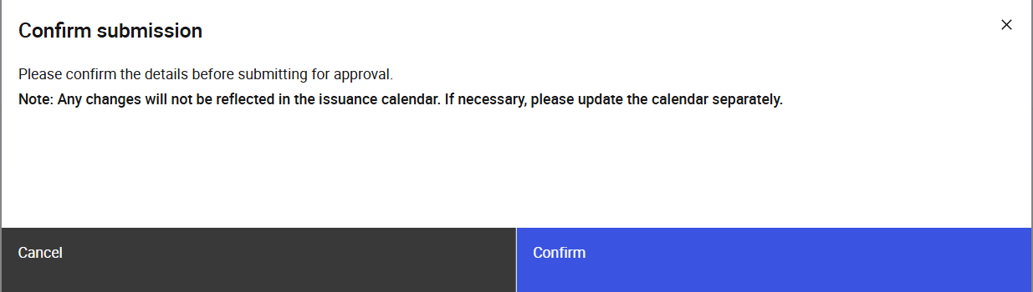
Figure 9: Confirmation Prompt

Screen Elements
S/N | Name | Type  (Max Length) | Validation Rules | Remarks
1 | Confirm submission | Modal title
2 | Please confirm the details before submitting for approval.  Note: Any changes will not be reflected in the issuance calendar. If necessary, please update the calendar separately. | Modal description
3 | Cancel | Secondary button |  | Closes the confirmation prompt.
4 | Submit | Primary button |  | Submits the updated announcement for syndication details. Refer to 2.8.4 Post Conditions.
Table 14: Confirmation Prompt Screen Elements

Approve/Reject Syndication Details Approval Request

Description
This use case enables Checkers to approve or reject syndication details approval requests.

Preconditions
- User logs in to the Intranet Portal.
- Syndication details were updated / Syndication was cancelled by a Maker and submitted for approval.
- The announcement is of the status “Pending Approval”.
- User accesses the Syndication Details Page.

Business Requirements
- Role-based Access Control:
  - Syndication Details Checker
- Checkers are not allowed to approve or reject the syndication details which they have submitted for approval, as they may hold both maker and checker roles.
- Checkers must enter remarks before being able to reject syndication details.

Post Conditions
- The syndication details status is updated based on the approval outcome:
  - Update – Approved: Status becomes either "Pending MEPS+" (awaiting MEPS+ information) or "Published" (published to MAS website).
  - Update – Rejected: Status either reverts to the previous status or becomes "Rejected", depending on what the previous status was.
  - Cancellation – Approved: Status becomes “Cancelled”.
  - Cancellation – Rejected: Status either reverts to the previous status or becomes "Rejected", depending on what the previous status was.
Refer to 2.5 State Transition Diagrams for the conditions for each of the different scenarios.
- If the information from MEPS+ is valid or the syndication details status is “Published”, OMEGA sends the approved syndication details to the MAS Website. Publication of the issuance calendar to the PDs will also be sent if there is a change to the value of Yield (%) in the syndication details, if the yield is approved to a blank value or syndication is cancelled, the issuance calendar will be sent with the syndication row relating to this issuance removed.
Refer to the MAS_OMEGA – Interface Specifications Document (MAS Website).docx for more details. Emails are also sent upon publication of the announcement.
- On the first verification with MEPS+ the Syndication Allotment Record will be created. If the value of “Conduct retail allotment in OMEGA” is “Yes”, the relevant bid collation record will be created as well. The web form for online submission of bids will also become available to the relevant users.
- Emails are sent to inform users that the syndication details have been approved or rejected.
- User views a temporary toast notification informing that the approval or rejection was successful.

Syndication Details Page
The page will be viewed If there are changes to the syndication details fields the previous value will be displayed below it in blue ().
Refer to 2.7.6 Syndication Details Page for the screen elements in the Syndication Details page. In this use case, the page contains additional elements in the Action Button Row.

Wireframe
Refer to 2.7.6.1 Wireframe.

Action Button Row
S/N | Name | Type  (Max Length) | Validation Rules | Remarks
1 | Reject | Secondary button |  | Opens the confirmation prompt.  Disabled if the Checker is also a Maker that submitted the request to update the syndication details for approval.
2 | Approve | Primary button |  | Opens the confirmation prompt.  Disabled if the Checker is also a Maker that submitted the request to update the syndication details for approval.
Table 15: Action Button Row Screen Elements

Confirmation Prompt

Wireframe
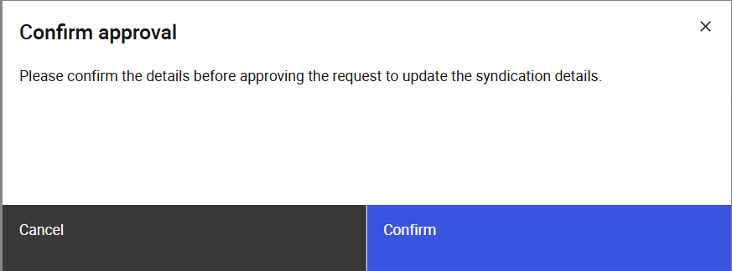
Figure 10: Confirmation Prompt Modal (Approve)

Screen Elements
S/N | Name | Type  (Max Length) | Validation Rules | Remarks
1 | *Refer to remarks | Modal title |  | When the “Reject” button is clicked, “Confirm rejection” is displayed.  If the “Approve” button is clicked, “Confirm approval” is displayed.
2 | *Refer to remarks | Modal description |  | When the “Reject” button is clicked, “Please confirm the details before rejecting the request to {requestType} the syndication details.” is displayed.  E.g. “Please confirm the details before rejecting the request to update the syndication details.”  If the “Approve” button is clicked, “Please confirm the details before approving the request to {requestType} the syndication details.” is displayed.  E.g. “Please confirm the details before approving the request to update the syndication details.” or “Please confirm the details before approving the request to unpublish this syndication details.”
3 | Cancel | Secondary button |  | Closes the confirmation prompt
4 | Confirm | Primary button |  | Approves the update request that was submitted for approval. Refer to 2.9.4 Post Conditions.
Table 16: Confirmation Prompt Screen Elements

Cancellation Banner
Only visible if 2.11 Cancel Syndication has been triggered.
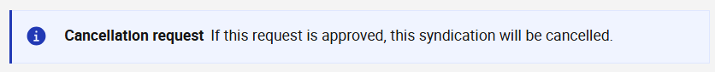
Figure 11: Cancellation Banner (displayed under the Page Sub-Header)

Screen Elements
S/N | Name | Type  (Max Length) | Validation Rules | Remarks
1 | Cancellation request | Banner title
2 | If this request is approved, this syndication will be cancelled. | Banner description
Table 17: Cancellation Banner Screen Elements

Withdraw Syndication Details Approval Request

Description
This use case enables Makers to withdraw syndication details updates/cancellations from approval. This is typically used when approval for the syndication details is not required at the point in time i.e., there are further updates to be made to the syndication details, or the updates that were submitted for approval are no longer required.

Preconditions
- User logs in to the Intranet Portal.
- User accesses the Syndication Tab of the Announcement Details Page.
- The announcement is of the status “Pending Approval”.

Business Requirements
- Role-based Access Control:
  - Syndication Details Maker

Post Conditions
- The instance of the BPMN workflow that was created when the syndication details was submitted for approval is suspended.
- The status of the syndication details is updated based on its previous status, refer to 2.5 State Transition Diagram.
- The event is added to the audit log and submission history.
- Emails are sent to the checkers to inform them of the syndication details which was withdrawn.
- User is redirected back to the Syndications Tab of the Announcement Listing Page.
- User views a temporary toast notification informing that the withdrawal was successful.

Syndication Details Page
Refer to 2.7.6 Syndication Details Page for the screen elements in the Syndication Details page. In this use case, the page contains additional elements in the Page Header.

Wireframe
Refer to 2.7.6.1 Wireframe.

Page Header
S/N | Name | Type  (Max Length) | Validation Rules | Remarks
1 | Withdraw | Tertiary button |  | Opens the confirmation prompt.
Table 18: Page Header Screen Elements

Confirmation Prompt

Wireframe
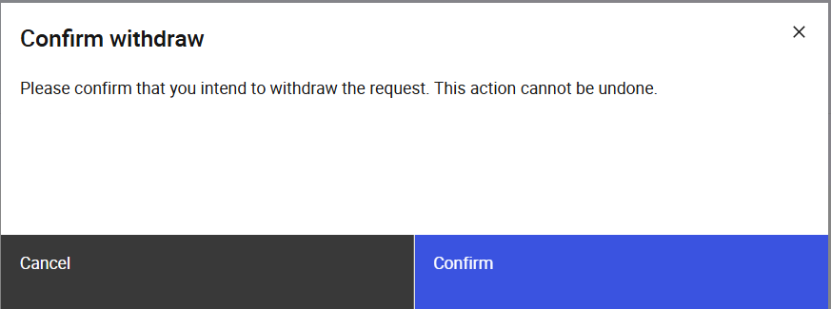
Figure 12: Confirmation Prompt (Withdraw)

Screen Elements
S/N | Name | Type  (Max Length) | Validation Rules | Remarks
1 | Confirm withdrawal | Modal title
2 | Please confirm that you intend to withdraw the request. This action cannot be undone. | Modal description
3 | Cancel | Secondary button |  | Closes the confirmation prompt.
4 | Confirm | Primary button |  | Withdraws the approval request submitted for the syndication details.  Refer to 2.10.4 Post Conditions.
Table 19: Confirmation Prompt Screen Elements

Cancel Syndication

Description
This use case enables Makers to request for syndications to be cancelled. This is typically used when there is not enough demand for the syndication. The request must be approved by a Checker before the syndication is cancelled.

Preconditions
- User logs in to the Intranet Portal.
- User accesses the Announcement Details Page.
- The syndication details can be at any status.

Business Requirements
- Role-based Access Control:
  - Announcement Maker

Post Conditions
- An instance of the BPMN workflow is created.
- The status of the syndication details is updated to “Pending Approval”.
- The event is added to the audit log and submission history.
- Emails are sent to the checkers to inform them of the syndication which was requested to be cancelled.
- User is redirected back to the Syndications Tab of the Announcement Listing Page.
- User views a temporary toast notification informing that the unpublish request was sent.

Confirmation Prompt
On clicking of the “Cancel syndication” button as described in 2.7.6.2 Page Header, the following confirmation prompt will be displayed.

Wireframe
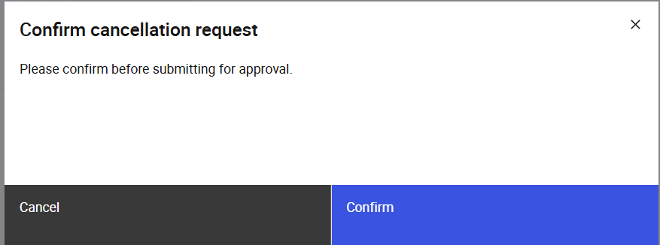
Figure 13: Confirmation Prompt

Screen Elements
S/N | Name | Type  (Max Length) | Validation Rules | Remarks
1 | Confirm cancellation request | Modal Title
2 | Please confirm before submitting for approval. | Modal Description
3 | Cancel | Secondary button |  | Closes the confirmation prompt.
4 | Submit | Primary button |  | Refer to 2.11.4 Post Conditions.
Table 20: Confirmation Prompt Screen Elements

Override MEPS+ Validation Error

Description
This use case enables Checkers to override any validation errors between MEPS+ and the syndication details data in OMEGA. This is typically used when there is a discrepancy between the syndication details in OMEGA and the data from secmast.txt file, and the data from MEPS+ is determined to be correct. The specific validations are as described in 3 Validations Against MEPS+. Discrepancy in fields that are referenced from the issuance calendar must be manually managed and updated from the issuance calendar.

Preconditions
- User logs in to the Intranet Portal.
- User accesses the Syndications Tab of the Announcement Details Page.
- The syndication details are of the status “MEPS+ Validation Error”.

Business Requirements
- Role-based Access Control:
  - Syndication Details Checker

Post Conditions
- The relevant fields from syndication details are updated with the values provided from MEPS+.
- User views a temporary toast notification informing that the override was successful.
- The status of the syndication details is updated to “Pending publication” and is published immediately.
- The event is added to the audit log and submission history.
- OMEGA sends the approved syndication details to the MAS Website. Refer to the MAS_OMEGA – Interface Specifications Document (MAS Website).docx for more details.
- Emails will be sent upon publication of the announcement.
- To ensure data synchronization, the issuance calendar must be updated manually if necessary.

Syndication Details Page
Refer to 2.7.6 Syndication Details Page for the screen elements in the Syndication Details page. In this use case, the page will contain additional elements in the Action Button Row.

Wireframe
Refer to 2.7.6.1 Wireframe.

Action Button Row
S/N | Name | Type  (Max Length) | Validation Rules | Remarks
1 | Override with MEPS+ | Primary button |  | Opens the confirmation prompt.
Table 21: Action Button Row Screen Elements

Confirmation Prompt

Wireframe
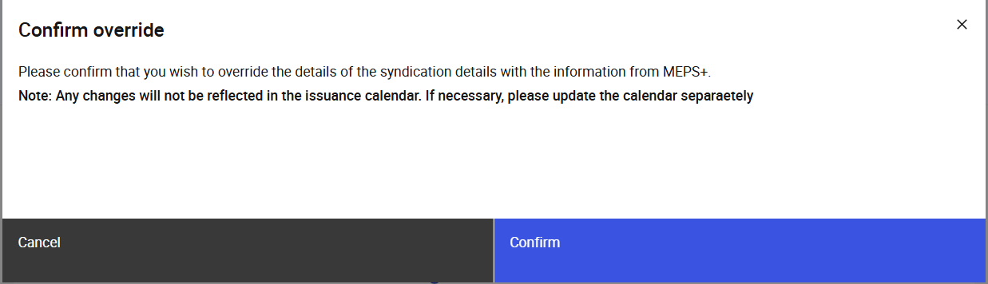
Figure 14: Confirmation Prompt Modal

Screen Elements
S/N | Name | Type  (Max Length) | Validation Rules | Remarks
1 | Confirm override | Modal Title
2 | Please confirm that you wish to override the details of the syndication details with the information from MEPS+.  Note: Any changes will not be reflected in the issuance calendar. If necessary, please update the calendar separately. | Modal Description
3 | Confirm | Primary button |  | Overrides the syndication details with the information from MEPS+. Refer to 2.14.4 Post Conditions.
Table 22: Confirmation Prompt Screen Elements

View Syndication Allotments

Description
This use case enables users to view and filter syndication allotments.

Preconditions
- User logs in to the Intranet Portal.
- User accesses the Syndication Allotment Listing Page.
- The syndication allotment record has been created following the verification with MEPS+

Business Requirements
- Role-based Access Control:
  - Syndication Allotment Maker
  - Syndication Allotment Checker
  - Syndication Allotment Viewer

Post Conditions
- User views the syndication details for a particular syndication allotment.

Syndication Allotment Listing Page
The Syndication Allotment Listing Page contains the following screen elements:
- Page Header
- Data Table Action Bar
- Data Table
Default Sorting: (1) descending order of allotment date, (2) ascending order of SGS type
Default Filter: Only show syndication allotment records whose allotment date is the current date.
Custom Filter Tag Behaviour: Refer to MAS_OMEGA – Functional Specifications Document (Common Functions).docx

Wireframe
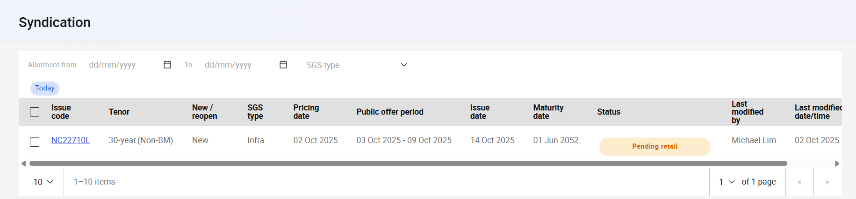
Figure 15: Syndication Allotment Listing Page

Page Header
S/N | Name | Type  (Max Length) | Validation Rules | Remarks
1 | Syndication | Page title
Table 23: Page Header Screen Elements

Data Table Action Bar
S/N | Name | Type  (Max Length) | Validation Rules | Remarks
1 | Allotment from | Date picker |  | To filter for Allotment date. The date selected is inclusive
2 | To | Date picker |  | To filter for Allotment date. The date selected is inclusive.  Earliest allowed date is the value of the Allotment from field. Latest allowed date is the current date.
3 | SGS type | Dropdown |  | Options available are:  - SGS (infra)  - SGS (MD)  - Green SGS (infra)  Additional options are available should new SGS type be added in in the parameter settings. Refer to the MAS_OMEGA – Functional Specifications Document (Administration).docx for more information.
Table 24: Data Table Action Bar Screen Elements

Data Table
S/N | Name | Type  (Max Length) | Validation Rules | Remarks
1 | Checkbox | Checkbox |  | This is to select the allotments meant for verification.  Allotments that are visible in the table but are not in “Pending verification” status will have this checkbox disabled.
2 | Issue code | Label (with hyperlink) |  | Clicking on the hyperlink navigates the user to the Syndication Allotment Page.
3 | Tenor | Label |  | For SGS bonds, add “(BM)” or “(Non-BM)” depending on whether the Benchmark field value is “Yes” or “No”.
4 | New / reopen | Label
5 | SGS type | Label
6 | Pricing date | Label
7 | Public offer period | Label
8 | Issue date | Label
9 | Maturity date | Label
10 | Status | Status Pill Indicator |  | Refer to 2.5 State Transition Diagram for possible values.
11 | Last action by | Label |  | Display the name of the user who made the last action that resulted in a change of status.  If it was an update by the system, “OMEGA” would be reflected as the user.
 | Last action on | Label |  | Display the date and time of the last action that resulted in a change of status.
Table 25: Data Table Screen Elements

Syndication Allotment Page
The Syndication Allotment Page contains the following screen elements:
- Page Header
- Sub-Header
- Submission History
- Overall Allotment
- Public Offer Results
- Public Offer Results (Data Table)
- Public Offer
- Placement Tranche
- Placement Tranche (Data Table)
- Internal Remarks
- Action Button Row

Wireframe
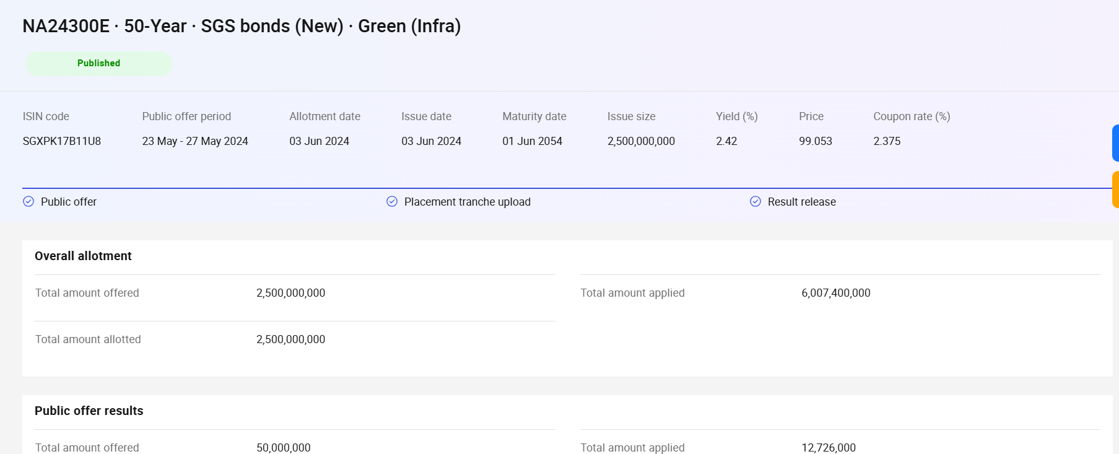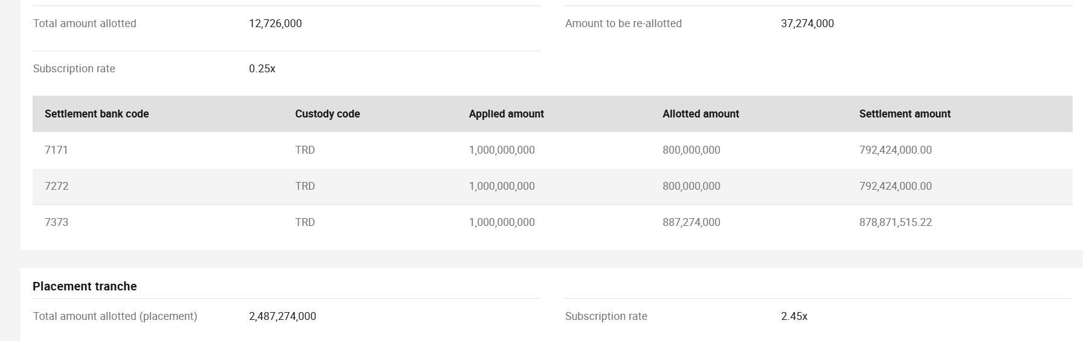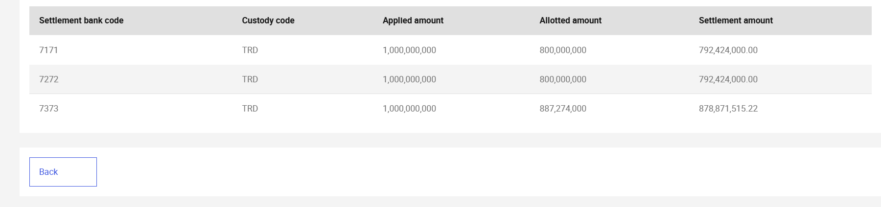
Figure 16: Syndication Allotment Page (Published status, Retail Allotment Outside of OMEGA)

Page Header
S/N | Name | Type  (Max Length) | Validation Rules | Remarks
1 | Page Title | Page Title |  | Displays the Security type and Issue code of the syndication as “{issueCode} ·  {tenor} · {securityType} ({newReopen})· · {sgsType}”  e.g. "N525100T·  5-year · SGS Bonds (Re-open) · SGS (MD)"
2 | Status | Status Pill Indicator |  | Displays the status of the announcement. For example, .
3 | Header Action Buttons | Button Group |  | Button availability is conditional based on the current state of the syndication allotment. Refer to the relevant use cases for specific button configurations. No buttons are universally available across all states.
Table 26: Page Header Screen Elements

Sub-Header
S/N | Name | Type  (Max Length) | Validation Rules | Remarks
1 | ISIN code | Label
2 | Public offer period | Label
3 | Allotment date | Label
4 | Issue date | Label
5 | Maturity date | Label
6 | Issue size | Label
7 | Yield (%) | Label
8 | Price | Label
9 | Coupon rate (%) | Label
10 | Progress Indicator | Progress Indicator |  | Displays the following steps:  - Public offer  - Placement tranche upload  - Result release  Refer to MAS_OMEGA – Functional Specifications Document (Common Functions).docx for the behaviour of a progress indicator.
Table 7: Sub-Header Screen Elements

Submission History
Refer to MAS_OMEGA – Functional Specifications Document (Common Functions).docx for the screen elements used and its functionalities.

Overall Allotment
This section is only visible if the status of “Pending verification”, “Pending Publication” and “Published”.
The values in this section should reference the combined values of the retail and placement tranches.
S/N | Name | Type  (Max Length) | Validation Rules | Remarks
1 | Total amount offered | Label
2 | Total amount applied | Label
3 | Total amount allotted | Label
Table 27: Overall Allotment Screen Elements

Public Offer Results
This section is only visible if:
- Status is “Pending Verification”, “Pending Publication”, or “Published”, OR
- “Conduct Retail Outside of OMEGA” for related syndication details = “Yes”
Though the names of the fields are identical to 2.13.6.5 Overall Allotment, the values in this section should reference the retail allotment data instead of the combined values of the retail and placement tranches.
S/N | Name | Type  (Max Length) | Validation Rules | Remarks
1 | Total amount offered | Label
2 | Total amount applied | Label
3 | Total amount allotted | Label
4 | Amount to be re-allotted | Label |  | This is to be calculated as the result of subtraction the total amount allotted (retail) from the total amount offered (retail).
5 | Subscription rate | Label
Table 28: Public Offer Results Screen Elements

Public Offer Results (Data Table)
This data table is nested in 2.13.6.6 Public Offer Results section. It is only visible if the “Conduct Retail Outside of OMEGA” for related syndication details = “Yes”.
S/N | Name | Type  (Max Length) | Validation Rules | Remarks
1 | Settlement bank code | Label
2 | Custody code | Label
3 | Applied amount ($) | Label
4 | Allotted amount ($) | Label
5 | Settlement amount ($) | Label
Table 29: Public Offer Results (Data Table) Screen Elements

Public Offer
This section is only visible if the status of the syndication allotment is “Pending retail” and the value of “Conduct retail allotment in OMEGA” is “Yes” in the related syndication details record.
The values in this section should reference the retail allotment data.
S/N | Name | Type  (Max Length) | Validation Rules | Remarks
1 | as of {current date time} hrs | Section Subtitle |  | Format of the date time will be “dd MMM yyyy, HH:mm”.  Text will be italicised.
2 | Total amount offered | Label
3 | Total amount applied | Label
Table 30: Public Offer Screen Elements

Placement Tranche
This section is only visible if the status of “Pending placement”, “Pending verification”, “Pending Publication” and “Published”.
The values in this section should reference the combined values of the retail and placement tranches.
S/N | Name | Type  (Max Length) | Validation Rules | Remarks
1 | Total amount allotted (placement) | Label |  | Will be “-“ if the placement tranche has not been uploaded / approved.
2 | Subscription rate | Label |  | Will be “-“ if the placement tranche has not been uploaded / approved.
Table 31: Placement Tranche Screen Elements

Placement Tranche (Data Table)
This data table is nested in 2.13.6.9 Placement Tranche section.
S/N | Name | Type  (Max Length) | Validation Rules | Remarks
1 | Settlement bank code | Label
2 | Custody code | Label
3 | Applied amount ($) | Label
4 | Allotted amount ($) | Label
5 | Settlement amount ($) | Label
Table 32: Placement Tranche (Data Table) Screen Elements

Internal Remarks
Refer to MAS_OMEGA – Functional Specifications Document (Common Functions).docx for the screen elements used and its functionalities.

Action Button Row
S/N | Name | Type  (Max Length) | Validation Rules | Remarks
1 | Back | Tertiary button |  | Redirects the user back to the Syndication Allotment Listing Page (2.13.5) retaining the filters previously selected.
Table 33: Action Button Row Screen Elements

Conduct Retail Allotment in OMEGA

Description
This use case enables the system to automatically conduct the retail bid collation and allotment for syndication securities within OMEGA when the "Conduct Retail Allotment in OMEGA" option is selected as "Yes".
The retail allotment process operates in the following phases:
Bid Collation Phase:
- Commences from public offer period start date and once the syndication details have been verified with MEPS+.
- OMEGA accepts retail bids according to the bid collation specifications.
- Bid validation and processing occurs in real-time.
Allotment Phase:
- Triggers automatically on allotment day at the time calculated from "Syndication retail allotment time" plus "Buffer time for allotment start"
- Applies the derivative Quantity Ceiling Format methodology for fair allocation. This is identical to the Quantity Ceiling Format in all ways except in name as the name has been legislatively reserved solely for the purpose of SSBs.
- Processes all valid bids according to the established allotment rules.
Result Release Phase:
- Generates allotment results and notifications.
- Updates system records and downstream interfaces.
- Completes audit trail documentation.
For more information on retail bid collation, refer to the MAS_OMEGA – Functional Specifications Document (Bid Collation).docx.
For more information on allotment, refer to the MAS_OMEGA – Functional Specifications Document (Allotment).docx.
For more information on the Quantity Ceiling Format, refer to the MAS_OMEGA – Functional Specifications Document (SSBs).docx.

Preconditions
- User logs in to the Intranet Portal.
- The syndication details have "Conduct Retail Allotment in OMEGA" radio button approved as "Yes".
- The public offer period has commenced.
- The syndication security is in "Published (MEPS+Verified)" status.

Business Requirements
- Role-based Access Control:
  - Auction Operator Checker

Post Conditions
- The announcement is updated with the values provided from MEPS+.
- Retail bids are accepted and collated throughout the public offer period.
- Retail allotment process executes automatically on allotment day at the configured time.
- Retail allotment results are generated and stored in the system.
- All bid collation and allotment activities are recorded in the audit log and submission history.
- OMEGA sends the retail allotment results to the MAS Website and to PDs. Refer to the MAS_OMEGA – Interface Specifications Document (MAS Website).docx and MAS_OMEGA – Interface Specifications Document FIs and CDP).docx and more details.
- Emails will be sent upon publication of the retail allotment results.

Upload Allotment File

Description
This use case enables Syndication Allotment Makers, to upload allotment files to fulfil use cases 2.18 Conduct Retail Allotment Outside of OMEGA and 2.19 Upload Placement Tranche. If there are errors with the file the user will not be able to submit the approval.

Preconditions
- User logs in to the Intranet Portal.
- User accesses the Syndication Allotment Page.
- The syndication allotment is of the status “Pending retail” (2.18 Conduct Retail Allotment Outside of OMEGA) or “Pending placement” (2.19 Upload Placement Tranche).
- User clicks on the upload button mentioned in the specific use cases mentioned in 2.15.1 Description.

Business Requirements
- Role-based Access Control:
  - Syndication Allotment Maker

Post Conditions
- The data table for the respective sections mentioned in the uses cases will be populated.

Upload File Modal

Wireframe
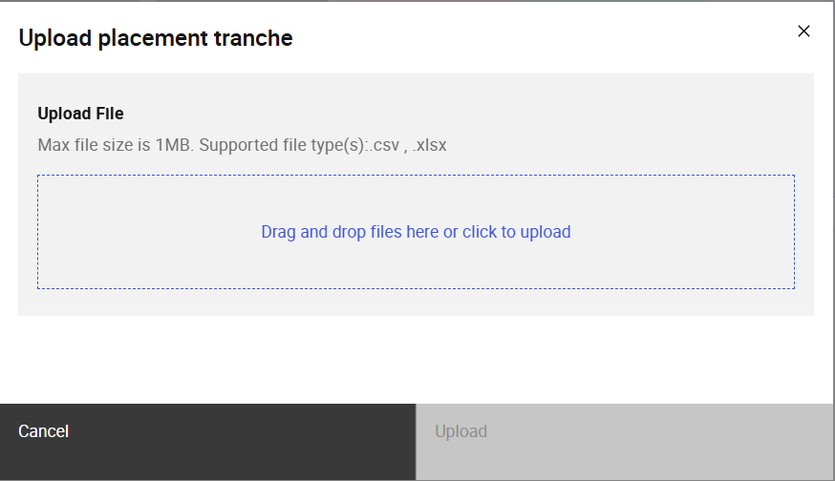
Figure 17: Upload File Modal

Screen Elements
S/N | Name | Type  (Max Length) | Validation Rules | Remarks
1 | Upload {file type} | Modal title |  | Placeholder {file type} mentioned in the Name column will either be:  - “retail allotment” in the 2.17 Conduct Retail Allotment Outside of OMEGA use case. Or;  - “placement tranche” in the 2.18 Upload Placement Tranche use case.
2 | Upload file | File upload container | Hard Validations:  - Mandatory field.
3 | Cancel | Secondary button |  | Closes the Upload File Modal.
4 | Upload | Primary button |  | Inputs the data from the file into the Syndication Allotment Page. Refer to the specific use cases mentioned in 2.15.7 Data Table for further information.  Disabled if there is no input in the mandatory field.
Table 34: Upload File Modal Screen Elements

File Format and Validations
The file should be in csv or xlsx format.
S/N | Name | Type  (Max Length) | Validation Rules | Remarks
1 | ISIN | Text  Max Length: 12 | Hard Validations:  - Must be equal to the ISIN code of the syndication allotment (case-insensitive)
2 | Issue code | Text  Max Length: 8 | Hard Validations:  - Must be equal to the Issue code of the syndication allotment (case-insensitive)
3 | Bank code | Numeric  Max Length: 4 digits | Hard Validations:  - Must be one of the bank codes received in bank.txt from MEPS+
4 | Custody code | Text  Max Length: 3 | Hard Validations:  - For retail, the value must be “CUS”  - For placement, the value must be “TRD”
5 | Applied amount | Numeric  Max Length: 11 digits (no decimal places) | Hard Validations:  - Cannot be zero  - Cannot be negative  -Must be completely divisible by minimum denomination of SGS Bonds
6 | Allotted amount | Numeric  Max Length: 11 digits (no decimal places) | Hard Validations:  - Cannot be negative  -Must be completely divisible by minimum denomination of SGS Bonds  - Must be less than or equal to the Applied amount.
7 | Settlement amount | Numeric  Max Length: 13 digits (including 2 decimal places) | Hard Validations:  - Cannot be negative  -Must match the calculated settlement amount from OMEGA, which is derived from the syndication allotment price and the allotted amount. | Refer to MAS_OMEGA – Functional Specifications Document (Allotment).docx for more information on the price/settlement amount calculations.
Table 35: File Validations

Data Table
S/N | Name | Type  (Max Length) | Validation Rules | Remarks
1 | Bank code | Numeric  Max Length: 4 digits
2 | Custody code | Text  Max Length: 3
3 | Applied amount | Numeric  Max Length: 11 digits (no decimal places)
4 | Allotted amount | Numeric  Max Length: 11 digits (no decimal places)
5 | Settlement amount | Numeric  Max Length: 13 digits (including 2 decimal places)
Table 36: Data Table Screen Elements

Approve/Reject File Upload Approval Request

Description
This use case enables Syndication Allotment Makers, to approve / reject allotment files to fulfil use cases 2.18 Conduct Retail Allotment Outside of OMEGA and 2.19 Upload Placement Tranche.

Preconditions
- User logs in to the Intranet Portal.
- Syndication allotment file was uploaded by a Syndication Allotment Maker and submitted for approval.
- The announcement is of the status “Pending Approval”.
- User accesses the Syndication Allotment Page.

Business Requirements
- Role-based Access Control:
  - Syndication Details Checker
- Checkers are not allowed to approve or reject the syndication allotment file upload which they have submitted for approval, as they may hold both maker and checker roles.
- Checkers must upload the same file that the Maker uploaded to approve the request.
- Checkers must enter remarks before being able to reject syndication allotment file upload request.

Post Conditions
- The syndication details status is updated based on the approval outcome:
Refer to 2.5 State Transition Diagrams for the conditions for each of the different scenarios and outcomes.
- Emails are sent to inform users that the syndication details have been approved or rejected.
- User views a temporary toast notification informing that the approval or rejection was successful.

Syndication Allotment Page
Refer to 2.7.6 Syndication Details Page for the screen elements in the Syndication Allotment page. In this use case, the page contains additional elements in the Action Button Row.

Wireframe
Refer to 2.7.6.1 Wireframe.

Action Button Row
S/N | Name | Type  (Max Length) | Validation Rules | Remarks
1 | Reject | Secondary button |  | Opens the confirmation prompt.  Disabled if the Checker is also a Maker that submitted the request to update the syndication details for approval.
2 | Approve | Primary button |  | Opens the confirmation prompt.  Disabled if the Checker is also a Maker that submitted the request to update the syndication details for approval.
Table 37: Action Button Row Screen Elements

Confirmation Prompt

Wireframe
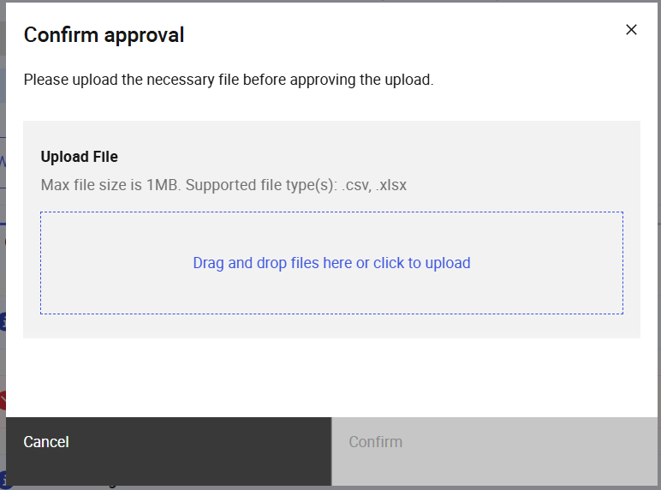
Figure 18: Confirmation Prompt Modal (Approve)

Screen Elements
S/N | Name | Type  (Max Length) | Validation Rules | Remarks
1 | *Refer to remarks | Modal title |  | When the “Reject” button is clicked, “Confirm rejection” is displayed.  If the “Approve” button is clicked, “Confirm approval” is displayed.
2 | *Refer to remarks | Modal description |  | When the “Reject” button is clicked, “Please confirm the details before rejecting upload.” is displayed.  If the “Approve” button is clicked, “Please upload the necessary file before approving the upload.” is displayed.
3 | Upload file | File upload container | Hard Validations:  - For Approve, Mandatory field. | Visible only for Approve.
4 | Cancel | Secondary button |  | Closes the confirmation prompt
5 | Confirm | Primary button |  | Disabled for Approve, when no file has been uploaded or the checksum does not match.  Approves / rejects the request. Refer to 2.16.4 Post Conditions.
Table 38: Confirmation Prompt Screen Elements

Withdraw Allotment File Upload Approval Request

Description
This use case enables Makers to withdraw syndication allotment uploads from approval. This is typically used when there is a need to update / correct the data in the uploaded file. This use case can be triggered as part of 2.17 Conduct Retail Allotment Outside of OMEGA and 2.18 Upload Placement Tranche

Preconditions
- User logs in to the Intranet Portal.
- User accesses the Syndication Allotment Page.
- The syndication allotment is of the status “Pending Approval”.

Business Requirements
- Role-based Access Control:
  - Syndication Details Maker

Post Conditions
- The instance of the BPMN workflow that was created when the syndication file upload was submitted for approval is suspended.
- The status of the syndication allotment is updated based on its previous status, refer to 2.5 State Transition Diagram.
- The event is added to the audit log and submission history.
- Emails are sent to the checkers to inform them of the syndication allotment request which was withdrawn.
- User is redirected back to the Syndications Allotment Listing Page.
- User views a temporary toast notification informing that the withdrawal was successful.

Syndication Allotment Page
Refer to 2.7.6 Syndication Details Page for the screen elements in the Syndication Allotment page. In this use case, the page contains additional elements in the Page Header.

Wireframe
Refer to 2.7.6.1 Wireframe.

Page Header
S/N | Name | Type  (Max Length) | Validation Rules | Remarks
1 | Withdraw | Tertiary button |  | Opens the confirmation prompt.
Table 39: Page Header Screen Elements

Confirmation Prompt

Wireframe
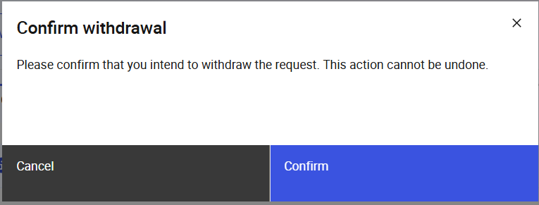
Figure 19: Confirmation Prompt

Screen Elements
S/N | Name | Type  (Max Length) | Validation Rules | Remarks
1 | Confirm withdrawal | Modal title
2 | Please confirm that you intend to withdraw the request. This action cannot be undone. | Modal description
3 | Cancel | Secondary button |  | Closes the confirmation prompt.
4 | Confirm | Primary button |  | Withdraws the approval request submitted for the syndication allotment.  Refer to 2.10.4 Post Conditions.
Table 40: Confirmation Prompt Screen Elements

Conduct Retail Allotment Outside of OMEGA

Description
This use case enables Makers to upload the retail allotment results to be approved when the allotment is conducted outside of OMEGA. This is typically used when the PDs are net yet able to integrate with OMEGA to conduct the syndication retail allotment. The request must be approved by a Syndication Allotment Checker.

Preconditions
- User logs in to the Intranet Portal.
- User accesses the Syndication Allotment Page.
- The syndication allotment is of the status “Pending retail”.
- The value of the “Conduct retail allotment in OMEGA” is “No” in the related syndication details record.
- Refer to 2.15 Upload Allotment File for more information on the file upload behaviour.

Business Requirements
- Role-based Access Control:
  - Syndication Allotment Maker

Post Conditions
- An instance of the BPMN workflow is created.
- The status of the syndication allotment is updated to “Pending Approval”.
- The event is added to the audit log and submission history.
- Emails are sent to the checkers to inform them of the syndication allotment which was requested for approval.
- User is redirected back to the Syndication Allotment Listing Page.
- User views a temporary toast notification informing that the unpublish request was sent.

Syndication Allotment Page
Refer to 2.7.6 Syndication Details Page for the screen elements in the Syndication Allotment page. In this use case, the page contains additional elements in the Page Header.

Wireframe
Refer to 2.7.6.1 Wireframe.

Page Header
S/N | Name | Type  (Max Length) | Validation Rules | Remarks
1 | Upload public offer | Tertiary button |  | Opens the Upload File Modal. Refer to 2.15.5 Upload File Modal.
Table 41: Page Header Screen Elements

Upload Placement Tranche

Description
This use case enables Syndication Allotment Makers to request for placement tranche uploads to be approved. This is typically used when the B&D Bank is unable to upload the placement tranche file themselves. The request must be approved by a Syndication Allotment Checker.

Preconditions
- User logs in to the Intranet Portal.
- User accesses the Syndication Allotment Page.
- The announcement is of the status “Pending placement” or “Pending verification”.
- Refer to 2.15 Upload Allotment File for more information on the file upload behaviour.

Business Requirements
- Role-based Access Control:
  - Announcement Maker

Post Conditions
- An instance of the BPMN workflow is created.
- The status of the syndication allotment is updated to “Pending Approval”.
- The event is added to the audit log and submission history.
- Emails are sent to the checkers to inform them of the syndication allotment which was requested for approval for the file upload.
- User is redirected back to the Syndication Allotment Listing Page.
- User views a temporary toast notification informing that the approval request was sent.

Syndication Allotment Page
Refer to 2.7.6 Syndication Details Page for the screen elements in the Syndication Allotment page. In this use case, the page contains additional elements in the Page Header.

Wireframe
Refer to 2.7.6.1 Wireframe.

Page Header
S/N | Name | Type  (Max Length) | Validation Rules | Remarks
1 | Upload placement tranche | Tertiary button |  | Opens the Upload File Modal. Refer to 2.15.5 Upload File Modal.
Table 42: Page Header Screen Elements

Verify Overall Allotment

Description
This use case enables Syndication Allotment Makers to verify the syndication allotments. Following this action the results and relevant interface files are published.

Preconditions
- User logs in to the Intranet Portal.
- User accesses the Syndication Allotment Listing Page.
- The syndication allotment is of the status “Published”.
- User selects and verifies the syndication allotment

Business Requirements
- Role-based Access Control:
  - Syndication Allotment Maker; or
  - Syndication Allotment Checker

Post Conditions
- The status of the syndication allotment is updated to “Pending publication”.
- The event is added to the audit log and submission history.
- The results and relevant interface files are sent.
- User is redirected back to the Syndication Allotment Listing Page.
- User views a temporary toast notification informing that the unpublish request was sent.

Syndication Allotment Listing Page
There are no specific changes to the Syndication Allotment Listing Page for this use case. Refer to 2.13.5 Syndication Allotment Listing Page

Download Allotment Result Report

Description
This use case enables Syndication Allotment Makers and Checkers to download a copy of the result reports. This is typically used when there is a need to check the results before verification.

Preconditions
- User logs in to the Intranet Portal.
- User accesses the Syndication Allotment Page.
- The announcement is of the status “Pending verification”, “Pending publication” or “Published”.

Business Requirements
- Role-based Access Control:
  - Syndication Allotment Maker
  - Syndication Allotment Checker
- For information on the content of the report, refer to MAS_OMEGA – Functional Specifications Document (Reports).docx.

Post Conditions
- Download of the report file is initiated to the user’s browser.

Syndication Allotment Page
Refer to 2.7.6 Syndication Details Page for the screen elements in the Syndication Allotment page. In this use case, the page contains additional elements in the Page Header.

Wireframe
Refer to 2.7.6.1 Wireframe.

Page Header
S/N | Name | Type  (Max Length) | Validation Rules | Remarks
1 | Download report | Tertiary button |  | Initiates the download of the report for the issuance.
Table 43: Page Header Screen Elements

Validations Against MEPS+
When processing the secmast.txt file from MEPS+, OMEGA compares the processed data against any syndication details that are of the status “Pending MEPS+” or “MEPS+ Validation Error”. In the table below, the first column indicates the fields in OMEGA. The values in the second to the last columns contain the fields in secmast.txt, if any, that would be validated against the corresponding syndication details field in OMEGA. Only values that are validated against MEPS+ are in the table below. If there are discrepancies between the value in the syndication details and MEPS+ it will be indicated in red (e.g. ) below the respective field.
OMEGA Field Name | SGS Bond  (Reopen) | SGS Bond  (New)
Total Amount Offered | QTY_OFFERED | QTY_OFFERED
MAS' Intended Tender Amount | MAS_APPLIED | MAS_APPLIED
Coupon Rate | INT_RATE
Coupon Payment Dates | INT_DATE1 and INT_DATE2 | INT_DATE1 and INT_DATE2
Next Coupon Payment Date | NEXT_INT_DATE
First Coupon Payment Date |  | NEXT_INT_DATE
Accrued Interest Payable by Investor | ACCRUED_INT_DAYS
Table 44:Validations Against MEPS+

